|  |  |
| --- | --- |
| weather and health  **Impact of climate change on health** | Justine Zecchini  First Year student - 2015 |

# Introduction

# This report presents the impacts of weather and climate change on human’s health. It can affect all the population in the world and has many aspects

This report is divided in three parts. The first part explains how natural disasters can impact human’s health, the second part presents consumption disasters and finally the third part introduces the all-day impacts of the weather.

The sources of information have been assigned with numbers in Bibliography which are used in the text.

# Natural disasters

1. Environment

Extreme weather events are becoming intense and frequent in all the part of the world. They have increased by more than three time since 1960s and each year there are 60000 deaths because of them.

First, extreme precipitation events like tropical storms, hurricanes or floods are increasing, these could cause many risks for children, adults and older adults because of injuries, death, problems of communication and social’s effects like an increase of homeless and poorer people.

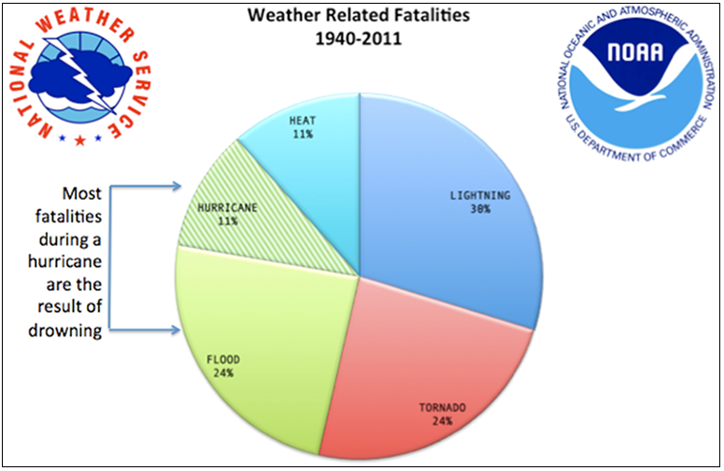This pie chart presents weather related facilities in the world between 1940 and 2011. Floods account for 24%, tornado account for 24%, lightning account fort 30%, hurricane and heat account for 22%. Hurricane and flood are causing most of fatalities because of the increase of drowning.

Figure 1: Weather related facilities between 1940 and 2011 (Source: http://mrcc.isws.illinois.edu/)

Global warming is the primary cause of the rising of sea levels, temperature and ice melting. It results in the warming and level increase of the ocean. In fact more than half of the world’s population lives next to the sea, and rising sea level is destroying homes, causing forced move and communicable disease. (10)(12)(23)(34)

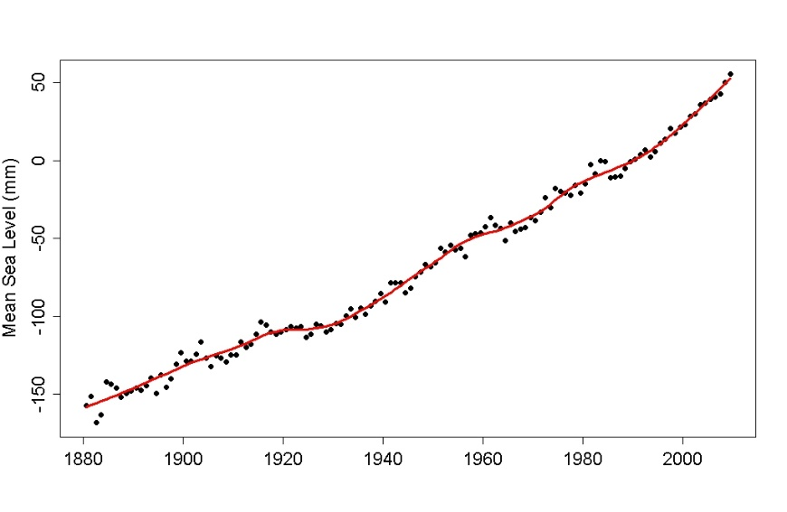This line chart depicts the changes of sea level between 1880 and nowadays. In 1880, sea level was at -150mm, until now, it has increased considerably and reached to 50mm.

Figure 2 : Mean sea level (Source : arstechnica.com)

1. Pollution

Chemicals, physicals or biological agents can modified the characteristics of the atmosphere, and it can contaminate indoor and outdoor. Vehicles, motors, industries are increasing air pollution. Pollutant’s quantity is raising in winter and summer because of weather conditions.

* Smog

Smog is a cloud of dirty air from cars, factories, etc. It happens when air pollution is higher than usual and it results from interactions between sunshine and chemicals of the atmosphere like nitrogen oxides, particulate matter and ozone.

Many health problems are caused because of smog:

* Ozone inflame airways, respiratory symptoms and asthma. In the USA, Red Ozone Alert Days increases by 68% in the eastern cities.
* Inhaling Particulate matters include premature mortality because of cardiovascular and respiratory diseases.
* Nitrogen dioxide causes bronchitis, asthma and other long-term diseases.
* Smog increases long and court diseases like pneumonia, coughing, cancers, etc.

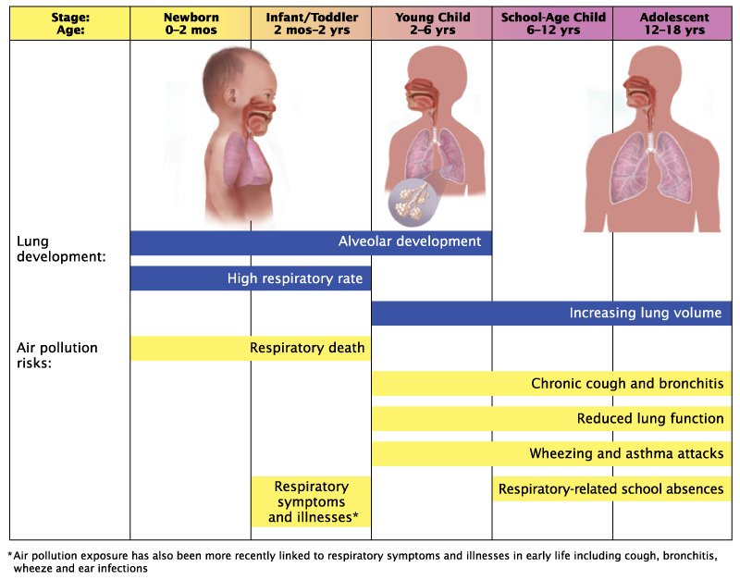This chart shows the development of respiratory ills for children between 0 to 18 years.

Figure 3 : Child respiratory ills (Source : environment.ucla.edu)

* From 0 to 6 years, alveolar development is high and pollution causes respiratory deaths, symptoms and illnesses.
* From 6 to 18 years, pulmonic volume is increasing and several diseases appear, including chronic cough, bronchitis, asthma, and reduced lung function.

WHO estimates that 80% of outdoor air pollution premature deaths are related to heart attack, 14% to obstructive pulmonary infections and 6% to cancers. Plus, 3 billion people have serious diseases because of indoor smoke and pollutants. It shows that ambient air quality is a real problem for human’s health nowadays in cities and rural lands. (6)(12)(34)

1. Extreme heat

Extreme heat leads dehydration, hurts and causes more deaths each year than hurricanes, lightning, tornadoes and floods combined. Everybody is at risk but adults over 65, children under 4, and people with medical problems are concerned more than the others, because of cardiovascular and respiratory diseases. For example in 2003, in Europe, more than 70000 deaths were recorded because of the big heat wave.

* Impacts of extreme heat on the human body

Global warming causes extreme heat and extreme heat hurts humans because body is not adapted to high temperature. When the environment warms-up over than 30°C, the body warms up by an increase of blood pressure to pump more blood and sweat production, by this way body can maintain its normal temperature, but this work uses more energy and body’s performances are decreasing, like mental tasks of physical performances.

* Symptoms of extreme heat

Symptoms of extreme heat and danger on health are function of the temperatures raises.

* **27°C – 32°C: Fatigue and sunburn**: Pains like redness, fever, and headaches.
* **32°C – 40°C: Heat cramps**: Spasms in muscles and heavy sweating.
* **40°C – 54°C: Heat exhaustion**: Heavy sweating and loss of body water, heart’s palpitations, visual disturbances, vomiting.
* **More than 54°C: Fatal heat like Heat stroke**: High body temperature, possible unconscious.
* Boston

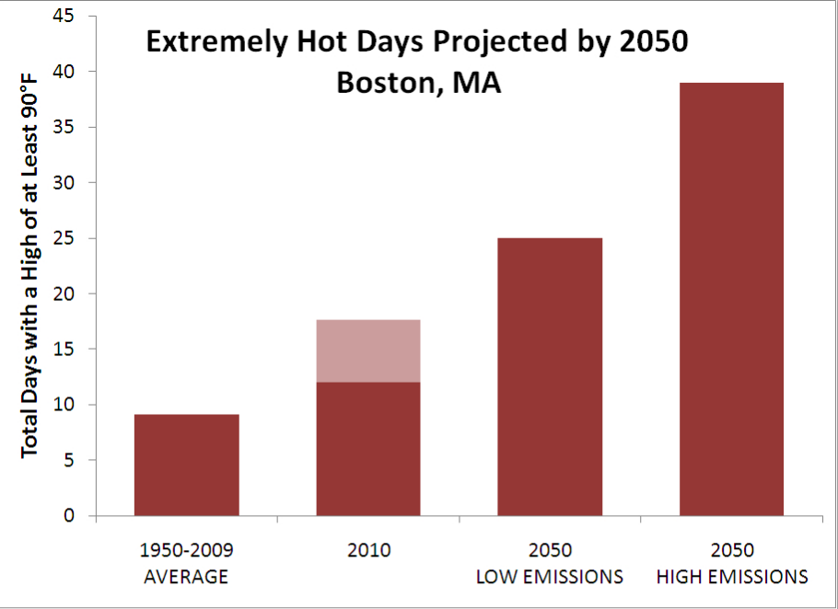This bar chart shows extremely hot days in Boston, between 1950 and a projection in 2050.

* 1950-2009 : 10 days with a high of at least 90°F (32°C)
* 2010 : Between 12 and 20 days with a high at least 90F (32°C)
* Projection in 2050 : Between 25 and 40 days with a high of at least 90F

Figure 4 : Extremely hot days projected by 2050 in Boston (Source: weather.about.com)

In only one century, extremely hot days are multiplied by four, and human’s body is not adapted to this. (6)(19)(23)(27)(34)

# Consumption disasters

1. Waterborne diseases

Actually, more than 748 million people in the world do not have access to potable water, and 2,5 billion people do not have access to sanitation and hygiene. Moreover, 840 OOO people are dying each year from waterborne diseases, adults and children.

Climate and weather lead the bad quality of the water. Extreme weather are increasing in many areas because of the explosion of the severity and the frequency of some precipitations. This exposes humans to pathogens, contaminants and a lower hygiene of the water. For example, UNICEF calculated that in Latin America and Caribbean "*between 1994 and 2003 the economic losses in water and sanitation were about $650 million, as a result of at least 2,100 urban systems damaged, 4,500 rural aqueducts affected, and 28,000 wells and 173,000 latrines destroyed due to natural disasters including floods, hurricanes, and more*” that can damaged quality of water and increase diseases called waterborne diseases.

* Examples of Waterborne diseases
* Cholera and diarrhoea

Cholera is a bacterial infection caused by Vibrio cholera. It is transmitted by water or food that has been polluted by human and by global warming. The mixing of safe water and waste water because of natural disasters like hurricane, poor hygiene and unsafe drunk-water multiply the risk of contamination.

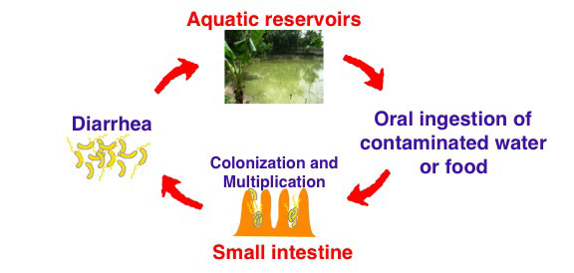**Life cycle:**

Figure 5 : Cholera life cycle (source : research.pomona.edu)

Aquatic reservoir and water have been contaminated, a human drinks the unsafe water and bacteria colonizes his intestine. Cholera causes severe diarrhoea, dehydration, vomiting and leg cramps, and because of dejection bacteria returns to water. Incubation time is between two hours to 5 days.

In 2008, 53 countries were considered endemic, mostly in Africa and East Asia.

* Hepatitis A

Hepatitis A is a viral infection caused by the HAV, it is transmitted by polluted-drinking water or by fish cultivated in polluted water and direct contact with infected person. Every year, 1.4 million cases of hepatitis A are declared.

The incubation period is between 14 to 28 days, after it, symptoms appear mild to severe. First, fever, diarrhoea, dark-coloured urine and jaundice, but liver, the major site of replication, can be affected by inflammations in a severe way.

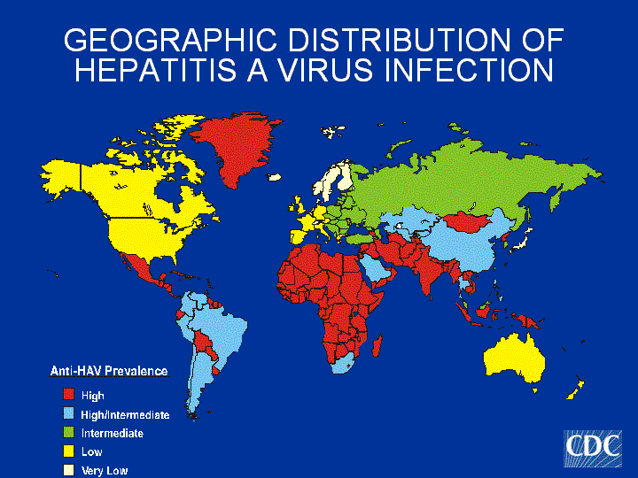Africa, India, Mexico, Middle East and Indonesia have the higher prevalence. Latin America, East Asia and South Africa have an intermediate prevalence. It shows that poorest countries have a biggest prevalence because of a lack of safe water. In developed countries like the USA, the prevalence is low, showing a large amount of safe water.

Figure 6 : Geographic distribution of Hepatitis A virus infection (Source : cdc.gov)

(5)(8)(10)(12)(21)(23)(30)(31)

1. Vector-borne diseases

Rainfalls and heavy precipitations are increasing the number of insects and leads to a development of vector-borne diseases. The geographic and seasonal distribution of the population of vectors depend on the climate. It directly affects vector-borne diseases in changing the ecosystem. Higher temperature increases the population of vectors that need water for their lifecycle, it also brings vector-borne in new geographic areas. Moreover, climate changes and decreases biodiversity of vector population predators, predator-prey relationships decrease and population of vectors raise. In the past year, it has been proved that Ebola vector-borne disease has been caused by global warming and the changes of climate conditions.

Infectious diseases are transmitted between human and between human and animals thanks to vector organisms like bloodsucking insects. Those diseases represent 17% of all infections. There are one billion cases and more than one million deaths every year.

* Malaria : Mosquito disease

Malaria is caused by a parasite called Plasmodium and carried by certain kind of mosquitoes. They are bloodsucker insects, only females can bite humans and transmit the disease. It can also be transmitted to the mother to her unborn infant and by blood transfusion.

In 2013, there were about 198 million cases of malaria, 584 000 deaths were declared and about 3.2 billion people were at risk in the world. Poorest countries are the most vulnerable, and 90% of all malaria deaths were in the African Region. Fortunately, since 2000 mortality has decreased by 47% in Africa. (Source: WHO)

* Transmission depends on climatic condition

Temperature affects the life of the mosquitoes, and how the malaria parasite quickly become mature to infect humans. Humidity increases the long life of mosquitoes, and give them more opportunities to infect human. Rainfall creates pools of water, and increase the humidity, by this way larva of mosquitoes are growing quickly, causing longer times of infections.

It has been proved that global warming has affected the distribution of the parasitism. Malaria has been introduced in higher altitude areas because of the raising of temperature.

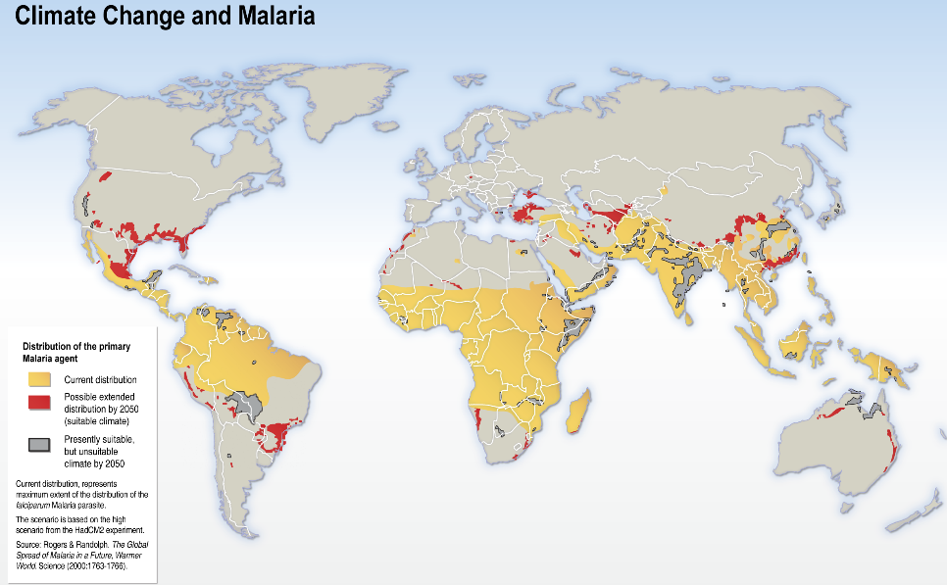 Africa, India, Sue-East Asia and the North of Latin America are the initial areas of infection. Global warming changes the distribution, by 2050 more countries will be touch, such in developed countries like the USA.

Figure 7 : Climate change and malaria (Source : acclimatise.uk.com)

* Symptoms

Symptoms appear between 8 and 30 days after the infection. The first symptoms are high fever, headache, vomiting. Within 24 hours, severe illnesses are caused, like anaemia, respiratory diseases and cerebral diseases.

Four types of malaria are existing, depending on the type of Plasmodium parasite, and each kind has his own complications.

(6)(8)(10)(19)(21)(22)(30)(33)(34)

# All days impacts on health

1. Seasonal diseases

Seasons are led by variation of climate, and seasons have effects on human’s health. Health depends on many characteristics like Temperature or pressure.

* Blood pressure

Blood pressure is changing all the time to maintain homeostasis within the body. When temperature changes, homeostasis changes and blood pressure must be adjust.

Many studies shows that in winter blood pressure is higher than in summer. In fact, lower temperatures strait blood vessels, which increase blood pressure because more power is needed to drive blood through narrow vessels.

Moreover, brutal changes in atmospheric pressure, wind and humidity can also create the same reaction, especially fort people age 65 and more.

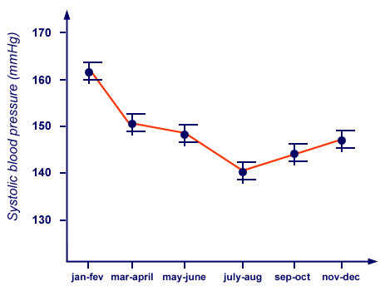This line chart shows the evolution of the blood pressure during a year.

Figure 8 : Evolution of systolic blood pressure during a year (Source: blood-pressure-hypertension.com)

* Between January-February, blood pressure is at its culmination : 160 mmHg
* Between march and august, it decrease to 140 mm Hg
* Blood pressure in raising from September to January, during the cold season.
* Heart attacks

Blood pressure affects the number of heart attacks, in winter and summer.

* When the temperature fall of 1°C, it is associated with 200 additional heart attacks. With cold, blood vessels constrict, heart has to pump more blood and work is too hard to keep the body safe. It has been shown that winter heart attack and other cardiovascular diseases are causing 26-36% more deaths than in summer.
* During extreme heat and humidity, body loses more water and it causes dehydration and heart strokes which are the result of extreme exposure to the sun. It causes fever, confusion, red skin, rapid pulse and vomiting. Children and people over than 65 are particularly in danger.

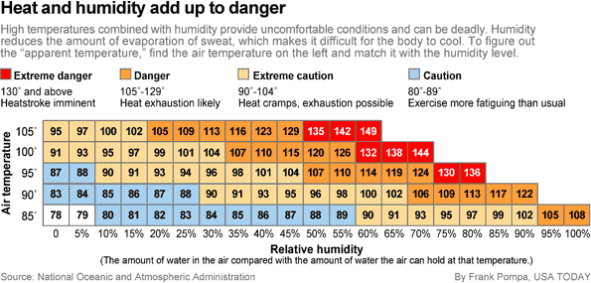

Figure 9 : Heat and humidity add up to danger (Source: National oceanic and atmospheric administration)

Combination of air temperature and relative humidity increase heart danger. Between 90 and 104F of apparent temperature, it is extreme caution with heart cramps. Between 105 and 129F of apparent temperature, it is danger with heart exhaustion likely. Finally over 130F of apparent temperature, it is extreme danger with heatstroke imminent.

* Allergen and asthma
* **Allergies** :

35 million Americans are allergic to pollen. With more CO2 in the air and more plant growth, pollen production increases dramatically. In 2000, pollen counts for 8450. Nowadays, pollen counts for 21700. It has been multiplied by three in four years. Moreover, with temperature changes, spring beginning 10 to 14 days earlier than it did 20 years before. Finally, it results an increase of number of allergies in all over the world.

* **Asthma** :

Over than 15million Americans have asthma, and it kills 180000 people all around the world each year. In the ten past years, asthma disease has increased more than 42%. This raise is caused by increase of pollen, severe allergies, and ground –level ozone.

* Headache

90% of women and 70% of men suffer from headaches. Environmental factors like temperature, bright light or air pollution can affect the pressure in the brain and are causing an increase of severe headaches. Migraine was risen by 7,5% for every 5°C increase.

* Diabetes

According to the International Diabetes Federation: “*there are currently 371 million people living with diabetes and another 280 million are at high risk of developing the disease. Half a billion people are expected to be living with diabetes by 2030*.”

In 2014, a link between climate change and diabetes has been highlighted. Climate causes migration of people, scarce of resources, increase of bad nutrition and food insecurity with the falling of nutritional values.

Diabetics are more vulnerable persons, they are predisposed to cardiovascular events and heatstroke increase mortality in those population. They have to be careful and eat plant-focused diet, but with global warming it will be more and more complicated, because of a lower production of good food. In a population in which 40% are obese, it is required 19% more food energy to avoid an increase of diabetes and Earth can not yield it.

In 2050, world’s population will grow to nine billion. Production, industrialization, gas emission and energy consumption will have to increase and it will drive type 2 diabetes and climate change.

(1)(2)(3)(4)(7)(11)(13)(14)(15)(17)(18)(24)(25)(28)(32)(34)

1. Mental and phobia disease

Mental illness is one of the causes of suffering in all over the world. It has been proved that extreme weather events can affect mental health, moreover, some patients with mental illness are more susceptible to climate changes

* Mental health
* **For patients:**

Climate change has negative effect on mental health: it influences depression, anxiety and stress. Patients with mental illnesses, such as schizophrenia, are at risk because climate and temperature can interfere with medications.

* **Natural disasters:**

Natural disasters affect mental health of the population, because of the traumatization of events. *“An intensely traumatic event will have a substantial effect on the mental health of many survivors*,” said psychologist and researcher Carl F. Weems, an associate professor at the University of New Orleans. “*The more severe and intense your exposure to traumatic experiences during a disaster, the more likely that you will have severe mental health symptoms. If you watch someone die or your house floods, you tend to have more intense effects.”* It has been proved that between 25-50% of people exposed to a natural disasters have some mental health effects.

* Phobias

A phobias can be develop of any object or situation, and all type of weather phenomenon can become a subject of phobia. Symptoms are anxiety, inability to sleep and panic.

List of some weather-phobias :

|  |  |
| --- | --- |
| **Phobia Name** | **Fear of...** |
| Ancraophobia, anemophobia | Wind or windstorms |
| Astraphobia, brontophobia, tonitrophobia | Thunder and lightning |
| Chionophobia | Snow |
| Lilapsophobia | Tornadoes or hurricanes |
| Nephophobia | Clouds |
| Ombrophobia | Rain |
| Thermophobia | Heat |

* Seasonal affective disorder

SAD is a depression related to seasonal pattern, it begins and ends at the same time each year, usually during autumn and winter. It has been linked with the reduced exposure to sunlight during this part of the year.

Sunlight stimulates the hypothalamus in the brain, which controls liberation of hormones. With a lack of light, stimulation decreases and production of hormones decreases too, and it touches the moods and causes SAD.

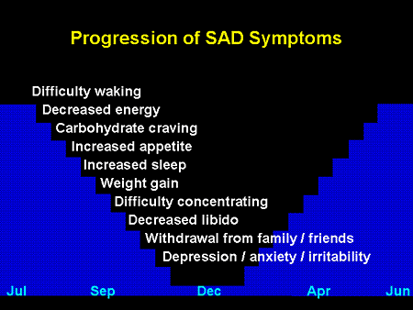 Seasonal affective disorder touch more 30 years person, especially women. In the UK, more than 6% of the population has recurrent SAD. Moreover, SAD touch 15% of patients with mood disorders like bipolar forms.

Progression of SAD depends on the month of the year, and symptoms are progressives. It begins with difficulty waking and decreased energy. It ends with depression, anxiety and irritability.

Figure 10 : Progression of SAD symptoms (Source: 5htppatch.co.uk)

(6)(9)(10)(19)(20)(21)(26)(29)(32)(34)

# Conclusion

The topic has presented impacts of climate and global warming on human’s health. It includes natural disasters with destruction of habitat and livelihood, and affects mental by traumatisms. Consumption is also affected, waterborne disaster and vector-borne disasters increase with global warming. Finally, impacts for humans exist all the years with seasonal diseases.

Based on the information presented in this report, it is clear that human health is affected in many ways by climate change, and concerned all the population in the world. Future challenge, is to decrease global warming and reduced his impacts on health. We have to reduce greenhouse effects by minimize gas emission, with cycling or biking instead of driving cars, for example. We have to provide research on human health impact, to know exactly effects of global warming and to adapt our way of life to it. We also have to preserve Earth, it has limits and populations have a role to play on the preservation of our heritage and our health.

# BIBLIOGRAPHY

(1) <http://beating-diabetes.com/index.php/diabetes-and-global-warming-the-link/>

(2) <http://edition.cnn.com/2009/HEALTH/03/10/headaches.weather/>

(3) <http://edition.cnn.com/2013/03/12/health/allergies-global-warming/>

(4) [http://environment.nationalgeographic.com/environment/global-warming/allergies-misery/?rptregcta=reg_free_np&rptregcampaign=2015012_invitation_ro_all#](http://environment.nationalgeographic.com/environment/global-warming/allergies-misery/?rptregcta=reg_free_np&rptregcampaign=2015012_invitation_ro_all)

(5) <http://water.org/water-crisis/water-facts/water/>

(6) <http://weather.about.com/od/climatechange/u/How-Weather-Affects-Your-Health-And-Mood.htm>

(7) <http://www.abc.net.au/health/thepulse/stories/2006/10/05/1749893.htm>

(8) <http://www.aboutkidshealth.ca/en/news/newsandfeatures/pages/after-the-floods-water-borne-and-vector-borne-diseases.aspx>

(9) <http://www.accuweather.com/en/weather-news/climate-weather-mentalhealth/16843803>

(10) <http://www.cdc.gov/climateandhealth/effects/>

(11) <http://www.colorado.edu/eeb/courses/1230jbasey/abstracts%202007/17.htm>

(12) <http://www.epa.gov/climatechange/impacts-adaptation/health.html>

(13) <http://www.hochdrucklabor.de/hypertension-and-climate-cooperation-german-weather-service-deutsche-wetterdienst-dwd?language=en>

(14) <http://www.hopkinsmedicine.org/healthlibrary/conditions/non-traumatic_emergencies/dehydration_and_heat_stroke_85,P00828/>

(15) <http://www.mayoclinic.org/diseases-conditions/high-blood-pressure/expert-answers/blood-pressure/faq-20058250>

(16) <http://www.mayoclinic.org/diseases-conditions/seasonal-affective-disorder/basics/symptoms/con-20021047>

(17) <http://www.mirror.co.uk/lifestyle/health/health-forecast-how-changing-weather-1892112>

(18) <http://www.mnn.com/earth-matters/climate-weather/stories/global-warming-and-the-asthma-epidemic>

(19) http://www.nhs.uk/

(20) <http://www.nhs.uk/conditions/seasonal-affective-disorder/Pages/Introduction.aspx>

(21) <http://www.niehs.nih.gov/>

(22) <http://www.nothingbutnets.net/blogs/the-connection-between-climate-change-and-malaria.html>

(23) [http://www.nwf.org/Wildlife/Threats-to-Wildlife/Global-Warming/Global-Warming-is-Causing-Extrem](http://www.nwf.org/Wildlife/Threats-to-Wildlife/Global-Warming/Global-Warming-is-Causing-Extreme-Weather.aspx)

(24) <http://www.nwf.org/Wildlife/Threats-to-Wildlife/Global-Warming/Global-Warming-is-Causing-Extreme-Weather/Allergies.aspx>

(25) <http://www.oneyoungworld.com/blog/protect-our-future-diabetes-and-climate-change>

(26) <http://www.patient.co.uk/doctor/seasonal-affective-disorder-pro>

(27) <http://www.srh.noaa.gov/ffc/?n=heat2>

(28) <http://www.theguardian.com/sustainable-business/blog/diabetes-diseases-climate-change-inequality>

(29) <http://www.ucsusa.org/global_warming/science_and_impacts/impacts/climate-change-and-mental-health.html#.VRhXE_msXuJ>

(30) <http://www.unicef.org/wash/index_wes_related.html>

(31) <http://www.wateraid.org/what-we-do/the-crisis/sanitation>

(32) <http://www.weather.com/health/news/13-ways-weather-affects-your-health-without-you-knowing-20140613#/1>

(33) <http://www.webmd.boots.com/travel/malaria?page=2>

(34) <http://www.who.int/>

Table of contents

Introduction 1

I. Natural disasters 1

A. Environment

B. Pollution

C. Extreme Heat

II. Consumption disasters 5

A. Waterborne diseases

B. Vector-borne diseases

III. All days impacts on health 8

A. Seasonal diseases

B. Mental and phobia diseases

Conclusion 13

BIBLIOGRAPHY 14